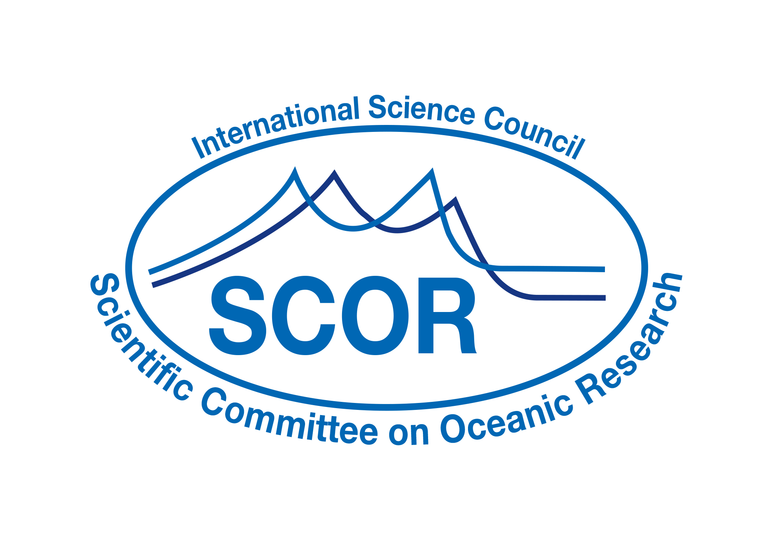
Call for 2019 SCOR Visiting Scholars

SCOR began a program in 2009 to enlist the services of ocean scientists from the SCOR community, from both developed and developing countries, to teach short courses and to provide more extended on-site education and mentorship at developing country institutions. This program is open to any Ph.D.-level scientist who has time available to spend teaching and mentoring in a developing country (see list here). The scholarships are not intended to conduct joint research, although such research may develop as an outcome of a visit.

Hosting visiting scientists can have many benefits to host institutions, such as inspiring, motivating, and informing students and faculty, and leading to future collaborations between the visiting scientist and the host institution.

The program is a partnership, with the host institution providing local accommodation and SCOR paying for airfares and other local expenses, as necessary. The participating scientists donate their time. They must be onsite for at least two weeks, but can also stay as long as visa requirements allow and hosts are willing to provide accommodations. Most successful applicants have identified a potential host institution.

SCOR, the Intergovernmental Oceanographic Commission, and the Indian Ocean Global Ocean Observing System program are co-sponsoring a project called the second International Indian Ocean Expedition (IIOE-2), so we would especially like to encourage SCOR Visiting Fellows who will work at institutions in the Indian Ocean region. However, applications for all regions of the world are welcome.

Awards for these scholarships are very competitive. For the 2018 program, 30 applications were received, but only 7 scholarships were awarded. The program has awarded scholarships to scientists at all career levels, from Ph.D. students to retired professors, but because the purpose of the program is teaching and mentoring, extensive experience in working with students gives applicants a higher chance of success. Such experience should be highlighted in the application along with specifics regarding knowledge exchange.

SCOR will select Scholars through its Committee on Capacity Building, which will review the applications and the proposed work assignments at the host institutions. The number of scientists placed each year will depend on the number of applications received and funding available. Criteria for selection will include the following:
- Quality and relevance of the proposal focusing on knowledge exchange and mentoring
- Experience of the candidate and fit with the program (language skills, teaching/mentoring experience, subject areas requested by the institution)
- Needs of the host institution
- Plans by the host institution to build upon the training received

SCOR will provide up to US$2,500 to pay for airfares and funds for meals for each Visiting Scholar and for insurance costs for those that do not have insurance.

The individual SCOR Visiting Scholar and institution will be responsible to ensure a successful outcome. SCOR will monitor the results of each partnership with a questionnaire to the visiting scientist and the host institution after the visit, to determine the effectiveness of the program and ways to make it more useful. SCOR will make every effort to create a sustainable program.

Report from Completed Scholar Visits
Following completion of a SCOR Visiting Scholar’s term, the Scholar is expected to submit a timely report to SCOR. This report should describe the experience and outcomes of the visit, recommendations to SCOR for future implementation of the Visiting Scholar program, and potential for future interactions with the host institution. Scholars will also be requested to respond to a short survey after their assignments.

Applications for the 2019 SCOR Visiting Scholars Program should be sent to Ed.Urban@scor-int.org by 14 December 2018.
Application for SCOR Visiting Scholars

Individuals interested in participating in this program should provide the following information:

Name and contact information of applicant

Experience in teaching and mentoring (one summary paragraph of 500 words total, plus a short CV of no more than 3 pages)

Languages spoken and written fluently—Many institutions in developing countries seek scientific instruction in English to help prepare them to interact with scientists from the global ocean science community, but may also prefer individuals with some knowledge of their national language.

Teaching plan, including how the impact of the training will be evaluated (maximum 500 words)

Countries/regions of interest (If a potential host institution has been identified, an invitation letter with the information requested in the following section should be provided)

Amount of time you are available and time range of availability

Coverage by health and accident insurance—Lack of coverage would not rule out any candidate, but would alert SCOR to the need to arrange such insurance.

This information will be made available to potential host institutions, but will not be posted on the Web in open-access format.

Application from Potential Host Institutions

Institutions interested in hosting a SCOR Visiting Scholar should provide the following information, in a short proposal describing the visiting scientist’s term at the host institution:

Help requested: teaching, mentoring in research, technology assistance, etc. (maximum 200 words)

Term of service desired, including specific dates

Local subsistence that will be provided by the host institution

Language abilities desired

Plans by the host institution to build on the training received, especially developing mechanisms for longer-term engagement between the Visiting Scholar and graduate students. Examples may include reciprocal visits by the students trained, becoming members of host institution graduate committees, etc. (500 words maximum)

Plans to conduct an evaluation of the effectiveness of the Visiting Scholar’s visit, using a survey provided by SCOR. This survey should be conducted by the host institution before the end of the Visiting Scholar’s visit. (200 words maximum0

SCOR Visiting Scholars (2009-2018)

Year | Name | Home Country | Host Country | Dates | Purpose
2009 | Paulo Relvas | Portugal | Guatemala | 2-16 July | Teach a course  on Physical Oceanography
2010 | Vadim Mokievsky | Russia | India | Sept. 20-Oct. 20 | Conduct field and lab training on Meiobenthos
2010 | Kurt Hanselmann | Switzerland | Namibia | Oct. 8-Nov. 7 | Teaching bio and chem oceanography
2011 | Ali Pourmand | USA | Iran | June 6 – July 12 | Help with paleo-oceanography workshop
2011 | Kurt Hanselmann | Switzerland | Namibia | 15 Sept.-6 Nov. | Will build on 2010 visit
2012 | Jacob Larsen | Denmark | Ghana | October 2012 | Teaching course on identifying harmful algae
2012 | René Swift | UK | South Africa/  Namibia | 23 Feb.-8 March 2012 | Provide training on marine mammal surveys
2013 | Geoff Millward | UK | Thailand | 21 Jan.-5 Feb. 2013 | Development of undergraduate and postgraduate courses in Marine and Coastal Resources and Environmental Sciences
2013 | Lisa Beal | USA | South Africa | 6-24 March 2013 | Teaching on physical oceanography
2013 | Alice Newton | Norway/  Portugal | Morocco | 10-25 May 2013 | Teaching on coastal lagoons
2013 | Jacob Larsen | Denmark | Namibia | April 2013 | Teaching course on identifying harmful algae
2013 | Michelle Graco | Peru | Argentina | December 2013 | Biogeochemical cycles and highly productive systems in the oceans
2014 | Halima Kiwango | Tanzania | South Africa/  Kwazulu Natal | Fall 2014 | Eco-hydrology and bio-hydrodynamics of coastal ecosystems
2014 | Prasanna Kumar | India | Bangladesh | August and October 2014 | Physical oceanography
2014 | Marcia Moreno-Baez | USA | Argentina | Completed in June 2014 | Participatory geographic information systems and the application of geospatial technology to collect local knowledge from fishers
2015 | Nagappa Ramaiah | India | Bangladesh | June 2015 | Teach biological oceanography
2015 | Tony Koslow | USA | Peru | 11 April–1 May 2015 | seminars/lectures on the development of ocean observation systems for sustainable management of marine ecosystems
2015 | Bill Burnett | USA | Brazil | 27 July-7 August 2015 | short course on “Applications of Isotopic Techniques for Coastal Studies”
2016 | Baban Ingole | India | Bangladesh | November-December 2016 | To teach biological oceanography at the Univ. of Dhaka
2016 | Jorge Santos | Norway | South Africa | August-Sept. 2016 | Training young scientists from Kenya Mozambique, South Africa, and Tanzania on techniques in fisheries science
2016 | Jacob Larsen | Denmark | Namibia | 15 Sept. – 6 Oct. 2016 | Teaching course on identifying harmful algae
2017 | Catherine Jeandel | France | Brazil | 17 June – 16 July | marine chemistry,  particularly trace elements and  isotopes
2017 | Josep Pelegri | Spain | Colombia | 18 May – 20 June | ocean circulation, emphasizing the basic  dynamic processes in the ocean at multiple time and space scales
2017 | Sam Dupont | Sweden | Costa Rica | 29 Oct.-12 Nov. | Experimental  design for ocean acidification  experiments
2017 | Janet Sprintall | USA | Indonesia | 24 Nov.-2 Dec. | introduction to physical oceanography, ocean  currents, and tides
2017 | Julia Jabour | Australia | Iran | June | Legal and policy status developments of the Southern Ocean in relation to  the Antarctic Treaty System and the UN Convention on the Law of the Sea
2018 | Baban Ingole | India | Bangladesh | TBD | Benthic ecology and biological oceanography
2018 | Cristian A. Vargas Gálvez | Chile | Ecuador | 19-28 Aug. | Ocean acidification lectures, lab, and field work
2018 | Julia M. Diaz | USA | Morocco | Nov. | Phosphorus biogeochemistry in the ocean
2018 | Manuel António E. Malaquias | Norway | Mozambique | 24 Aug.–9 Sept. | Curating marine biodiversity collections
2018 | Kedarnath Mahapatra | Japan | Indonesia | 7-20 Sept. 2018 | Combining satellite and in situ data from the Indian Ocean
2018 | Stuart P. Bishop | USA | Brazil | September | Physical oceanography
2018 | Ana Širović | USA | Croatia | Spring 2019 | Marine mammal bioacoustics

