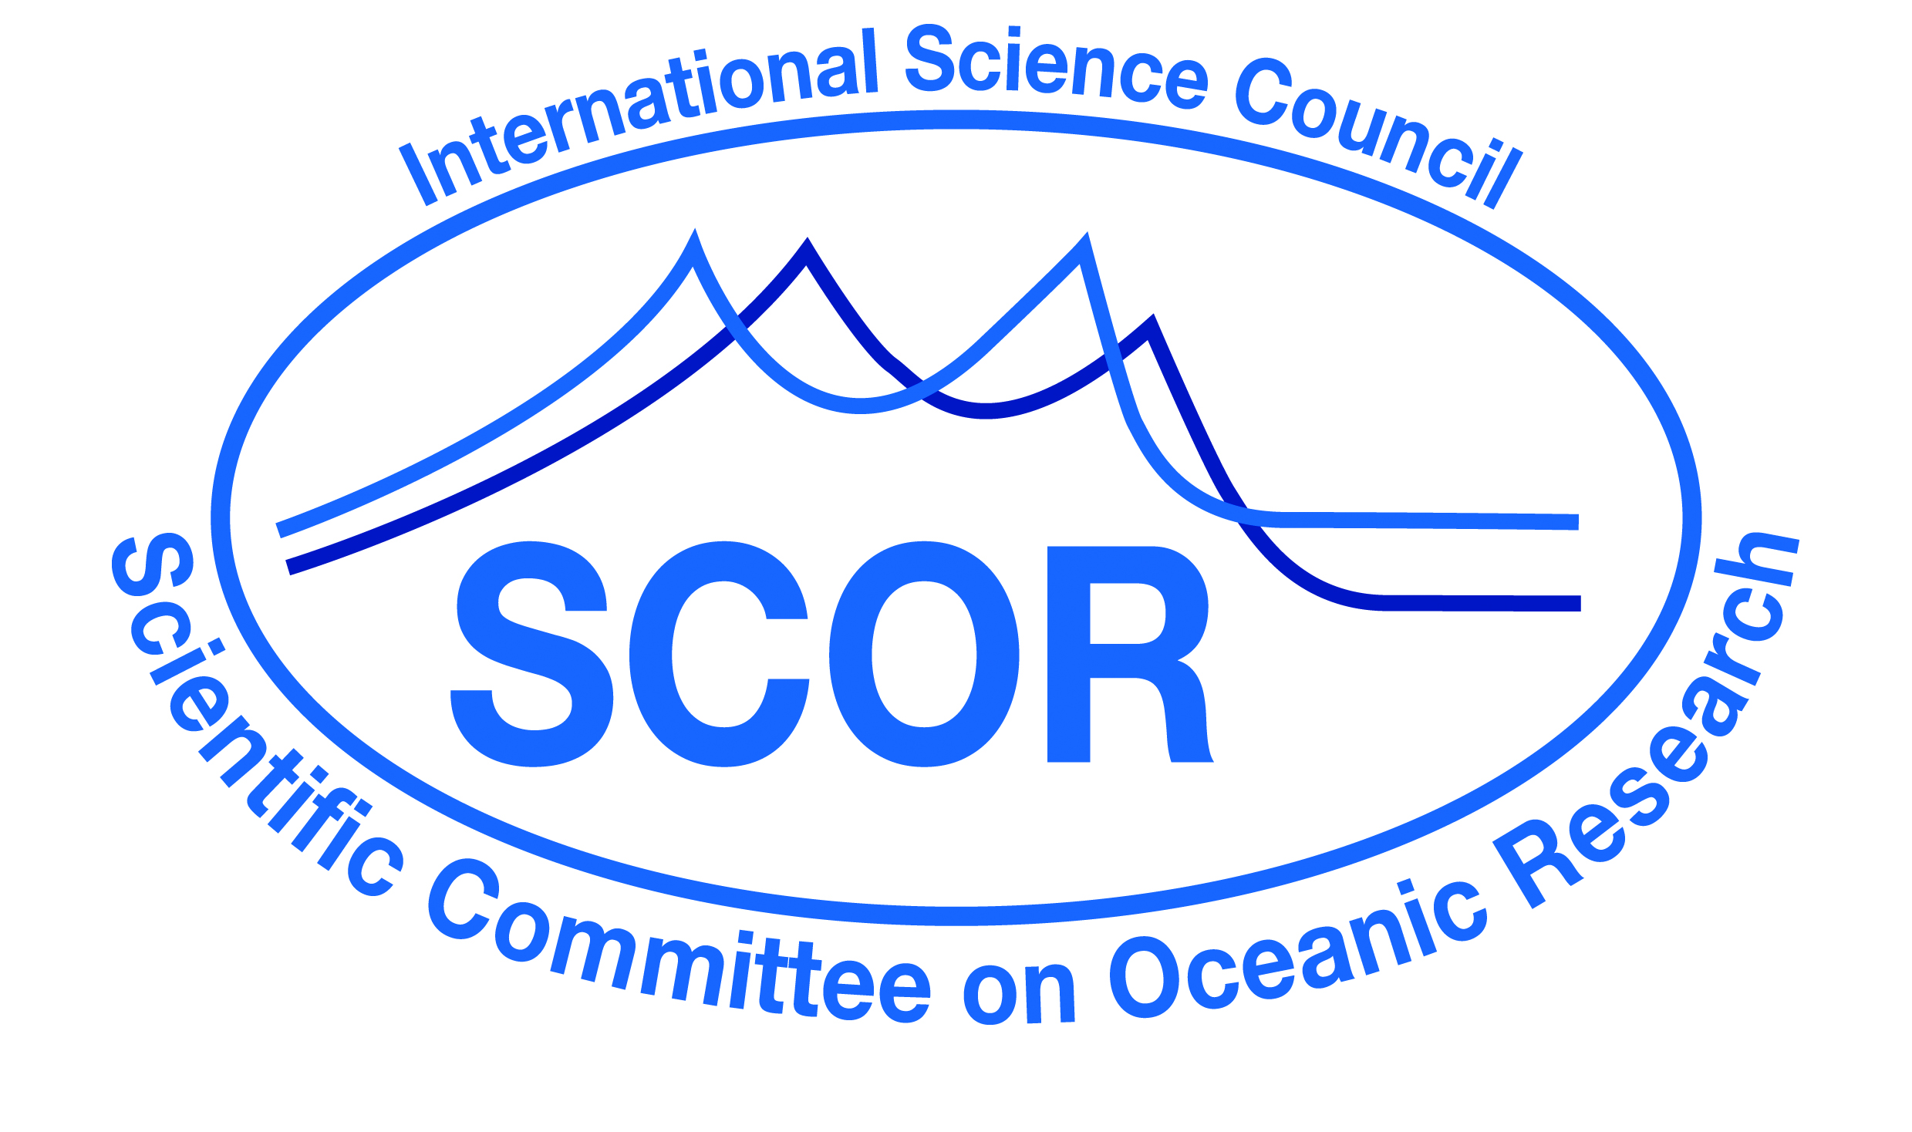
Call for 2020 SCOR Visiting Scholars

SCOR began a program in 2009 to enlist the services of ocean scientists from both developed and developing countries to teach short courses and to provide more extended on-site education and mentorship at developing country institutions. This program is open to any Ph.D.-level scientist who has time available to spend teaching and mentoring in a developing country (see list here). The scholarships are not intended to directly support research, although such research is encouraged as an outcome of a visit.

Hosting visiting scientists has many benefits to host institutions, such as inspiring, motivating, and informing students and faculty, and developing future collaborations between the visiting scientist and the host institution.

The program is a partnership between SCOR and local hosts. SCOR provides up to $2,500 for airfare and local expenses for each fellow; local hosts often provide local accommodation and may support some other local expenses. Local support from host institutions demonstrates institutional commitment to the visit. The participating scientists donate their time. They must be onsite for at least two weeks, but can also stay as long as visa requirements allow and hosts are willing to provide accommodations. Most successful applicants have identified a potential host institution.

SCOR, the Intergovernmental Oceanographic Commission, and the Indian Ocean Global Ocean Observing System program are co-sponsoring a project called the second International Indian Ocean Expedition (IIOE-2). We therefore would like to encourage SCOR Visiting Fellows who will work at institutions in the Indian Ocean region. However, applications for all regions of the world are welcome.

Awards for these scholarships are very competitive. For the 2019 program, 30 applications were received, but only 6 scholarships were awarded. The program has awarded scholarships to scientists at all career levels, from Ph.D. students to retired professors, but because the purpose of the program is teaching and mentoring, extensive experience in working with students gives applicants a higher chance of success. Such experience should be highlighted in the application along with specifics regarding knowledge exchange. A list of past SCOR Visiting Scholars can be found at http://www.scor-int.org/SCOR_CB/Scholars%20for%202009-2019.pdf.

SCOR will select Scholars through its Committee on Capacity Building, which will review the applications and the proposed work assignments at the host institutions. The number of scientists placed each year will depend on the number of applications received and funding available. Criteria for selection will include the following:
- Quality and relevance of the proposal focusing on knowledge exchange and mentoring. Applications that present a detailed plan for the visit are more likely to be successful.
- Experience of the candidate and fit with the program (language skills, teaching/mentoring experience, subject areas requested by the institution)
- Needs of the host institution
- Plans by the host institution to build upon the training received

The individual SCOR Visiting Scholar and institution will be responsible to ensure a successful outcome. SCOR will monitor the results of each partnership with a questionnaire to the visiting scientist and the host institution after the visit, to determine the effectiveness of the program and ways to make it more useful. SCOR will make every effort to create a sustainable program.

Report from Completed Scholar Visits
Following completion of a SCOR Visiting Scholar’s term, the Scholar is expected to submit a timely report to SCOR. This report should describe the experience and outcomes of the visit, recommendations to SCOR for future implementation of the Visiting Scholar program, and potential for future interactions with the host institution. Scholars will also be requested to respond to a short survey after their assignments.

Applications for the 2020 SCOR Visiting Scholars Program should be sent to Ed.Urban@scor-int.org by 1 December 2019.
Application for SCOR Visiting Scholars
(submit by 1 December 2019)

Individuals interested in participating in this program should provide the following information:

Name and contact information of applicant

Experience in teaching and mentoring (one summary paragraph of 500 words total, plus a short CV of no more than 3 pages)

Languages spoken and written fluently—Many institutions in developing countries seek scientific instruction in English to help prepare them to interact with scientists from the global ocean science community, but may also prefer individuals with some knowledge of their national language.

Teaching plan, including how the impact of the training will be evaluated (maximum 500 words)

Countries/regions of interest (If a potential host institution has been identified, an invitation letter with the information requested in the following section should be provided)

Amount of time you are available and time range of availability

Coverage by health and accident insurance—Lack of coverage would not rule out any candidate, but would alert SCOR to the need to arrange such insurance.

This information will be made available to potential host institutions, but will not be posted on the Web in open-access format.

Application from Potential Host Institutions of SCOR Visiting Scholars
(submit by 1 December 2019)

Institutions interested in hosting a SCOR Visiting Scholar should provide the following information, in a short proposal describing the visiting scientist’s term at the host institution:

Help requested: teaching, mentoring in research, technology assistance, etc. (maximum 200 words)

Term of service desired, including specific dates

Local subsistence that will be provided by the host institution (e.g., lodging, food, transportation, etc.)

Language abilities desired

Plans by the host institution to build on the training received, especially developing mechanisms for longer-term engagement between the Visiting Scholar and graduate students. Examples may include reciprocal visits by the students trained, becoming members of host institution graduate committees, etc. (500 words maximum)

Plans to conduct an evaluation of the effectiveness of the Visiting Scholar’s visit, using a survey provided by SCOR. This survey should be conducted by the host institution before the end of the Visiting Scholar’s visit. (200 words maximum)

